# Technical Writing Assignment: Creating and Refining Technical Instructions

Unit 5.1: Creating and Refining Technical Instructions

**Topic: How to Create and Optimize a Basic LinkedIn Profile**

**Instructions: How to Create a Basic LinkedIn Profile (12 Steps) 📝**

Follow these steps to create your professional LinkedIn profile and make a strong first impression.

**1.** **Open your web browser** (e.g., Chrome, Edge, Safari) and navigate to the LinkedIn homepage: www.linkedin.com.

**2.** **Click the 'Join now' button** located in the upper-right corner of the page.

**3.** **Enter your email address and choose a strong password** (at least 6 characters), then click 'Agree & Join.'

**4**. **Enter your first and last name on the next screen**, then click 'Continue.'

**5.** **Verify your identity by completing the simple security** check (usually a quick puzzle or CAPTCHA).

**6**. **Enter your current country and city**, then click 'Next.'

**7.** **Answer the questions about your current employment**:  
 - Indicate your job title, company, and employment type (e.g., Full-time).  
 - **Note for Students**: If you are a student, select the 'I'm a student' option and provide your institution and graduation year.

**8**. **Verify your email address**. Open the email from LinkedIn and click the verification link or copy and paste the 6-digit code into the setup window.

**9**. **Add a professional profile photo** by clicking the camera icon on the profile template.  
 Tip: Use a clear, recent headshot against a plain background.

**10.** **Write a compelling Headline.** This is the text directly under your name (e.g., Digital Marketing Specialist | SEO & Content Strategy).

11. **Complete the 'About' section** by clicking the pencil icon next to the section.  
 Write 3–5 short paragraphs summarizing your key skills, relevant experience, and career goals.

12. **Add at least one Work Experience or Education entry** by clicking the plus (+) icon on the respective section. Include the dates and a brief description of your role or studies.

## Visual Aid: LinkedIn Profile Screenshot 🖼️

**Step 1: LinkedIn Homepage**

Open your browser and go to [www.linkedin.com](http://www.linkedin.com)

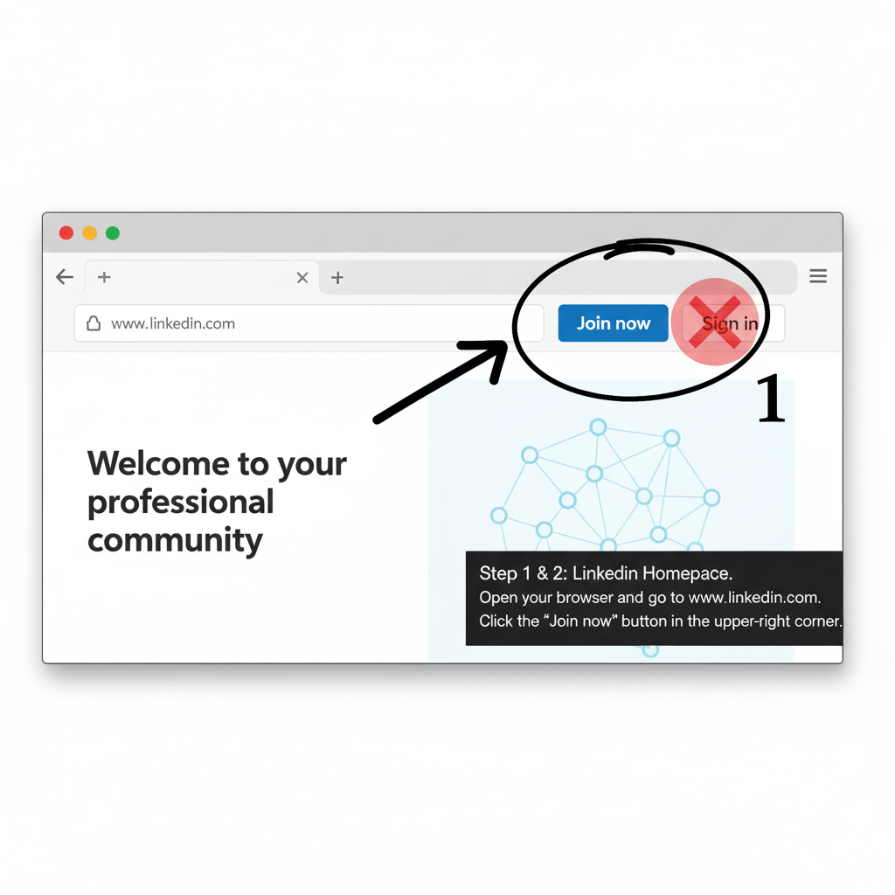

**Step 2: Sign-up Form**

Enter your **email address** and create a secure password (at least 6 characters).

Click “**Agree & Join.**

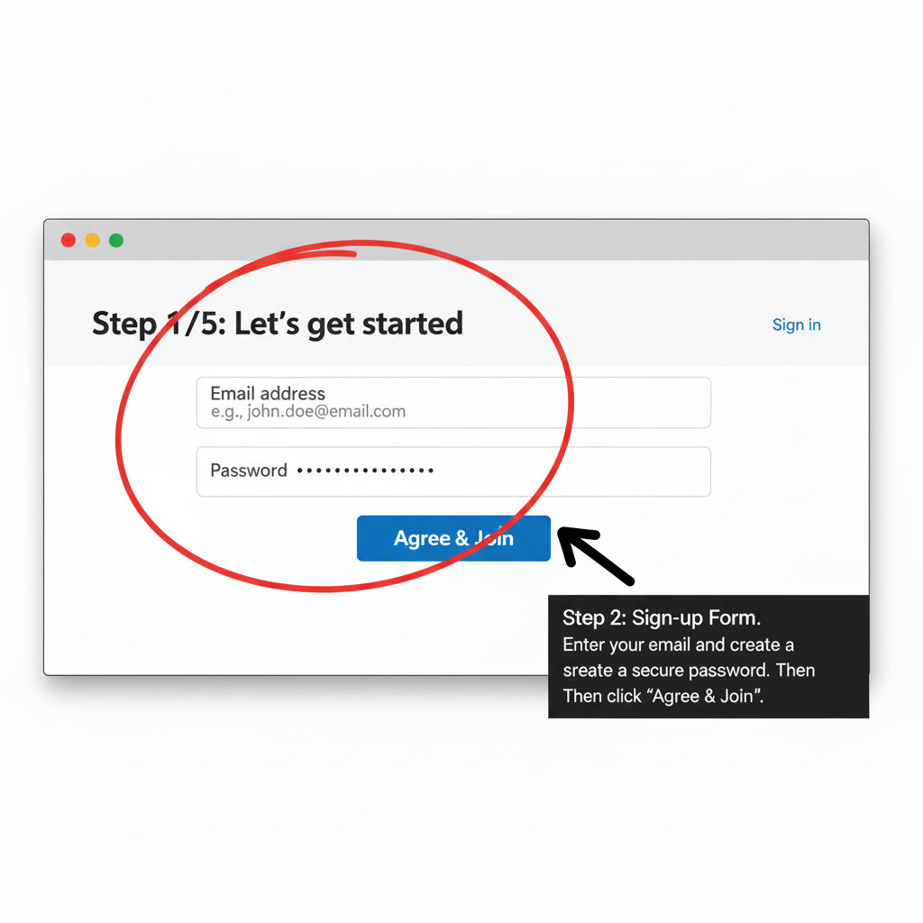

**Step 3: Personal Information**

Type your **first** and **last name**.

Click “**Continue**.”

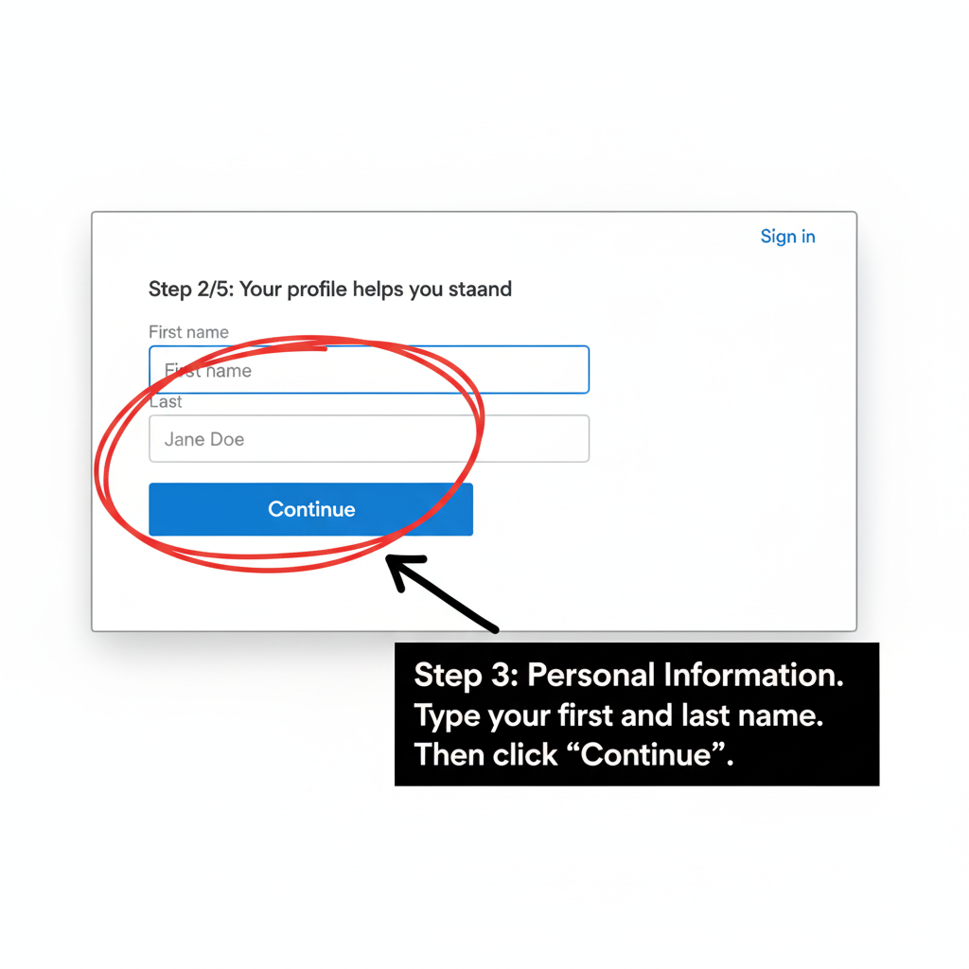

**Step 4: Verification**

Complete the **CAPTCHA** or **puzzle** to confirm you’re not a bot.

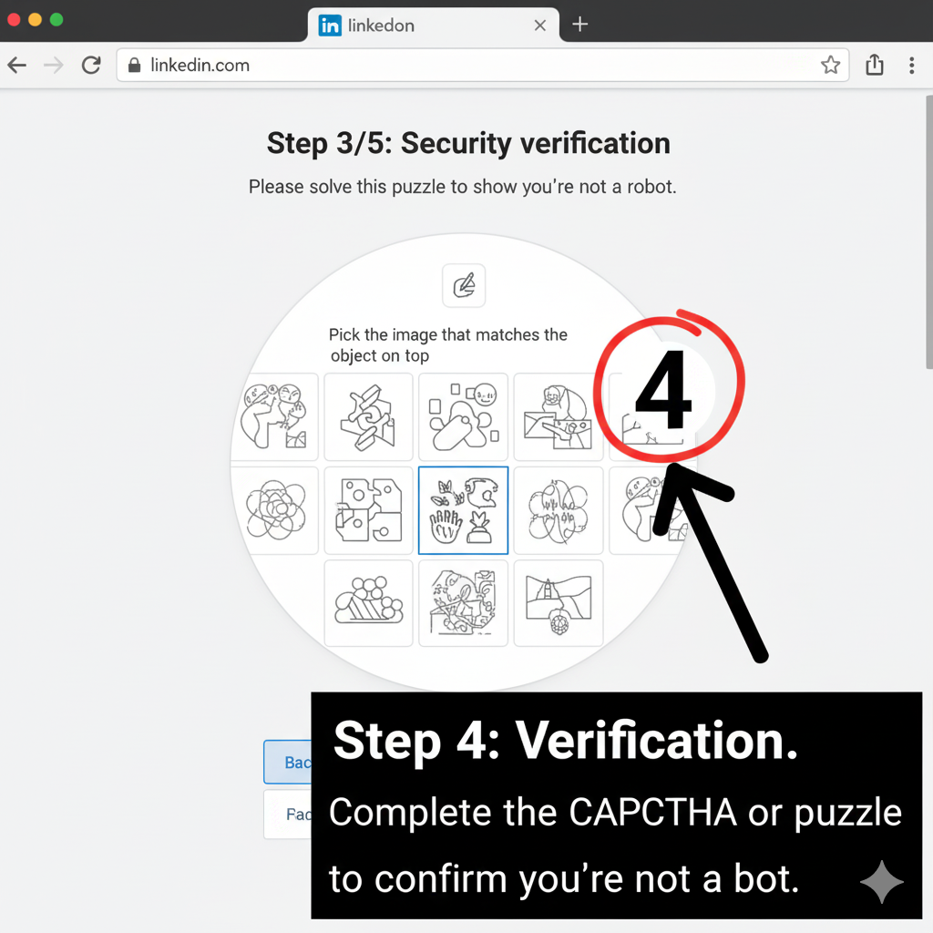

**Step 5: Location**

Select your **country** and **city.**

Click “**Next.”**

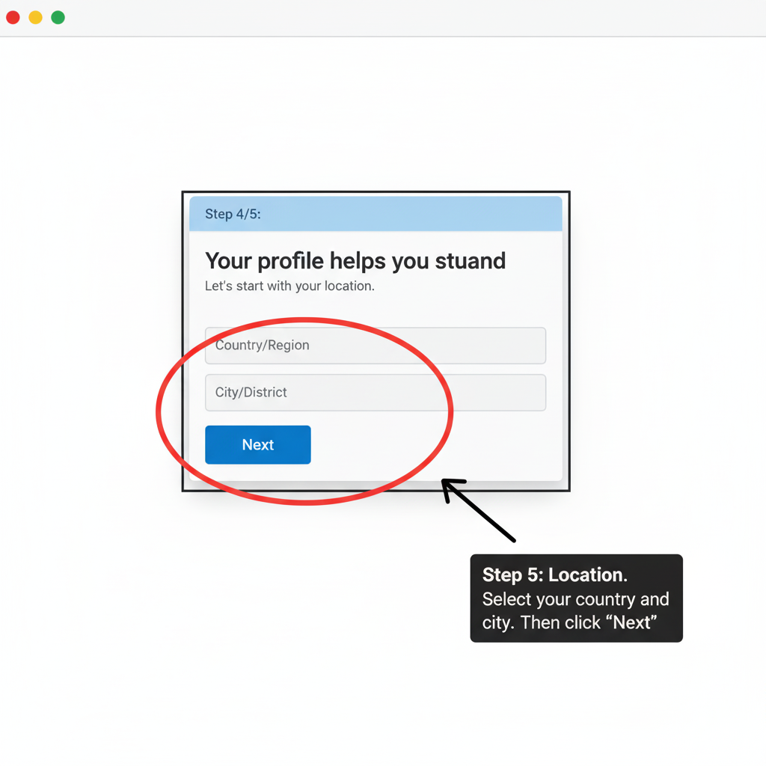

**Step 6: Employment or Student Info**

If employed: Enter your **job title**, **company**, and type of employment.

If a student: Select “**I’m a student**” and enter your **school name** and graduation year.

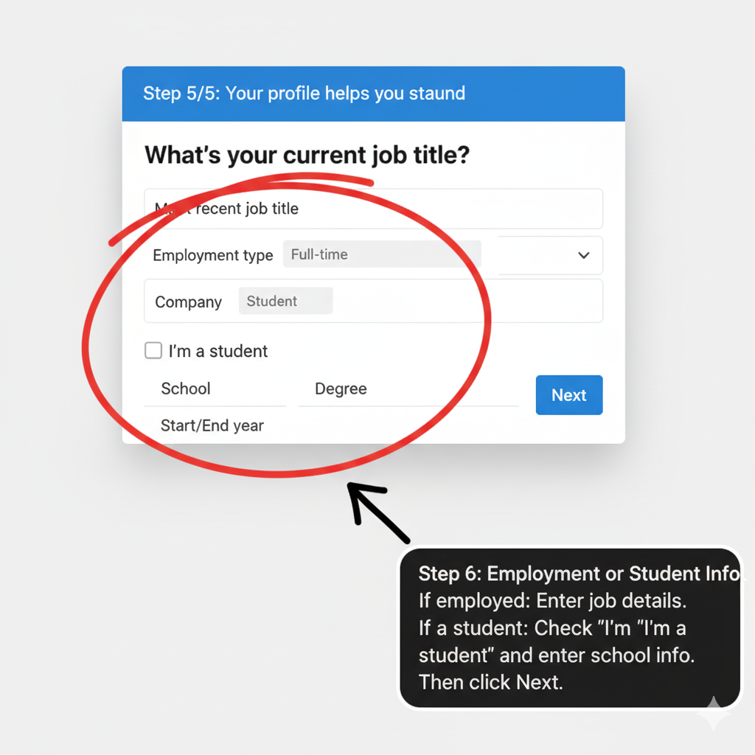

**Step 7: Email Verification**

Open your email inbox.

Click the **LinkedIn verification link** OR paste the **6-digit code** sent to you.

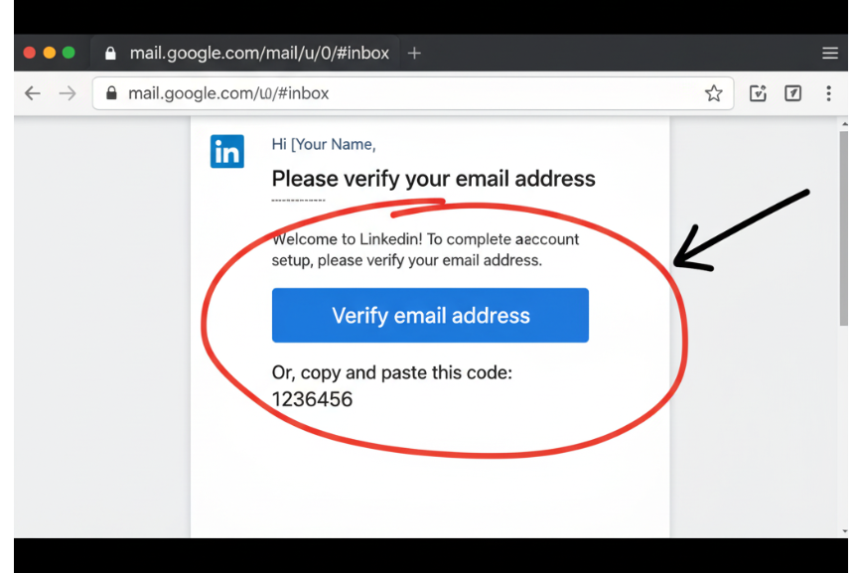

**Step 8: Upload Profile Photo**

Click the camera icon in the profile template.

Upload a clear, professional headshot.

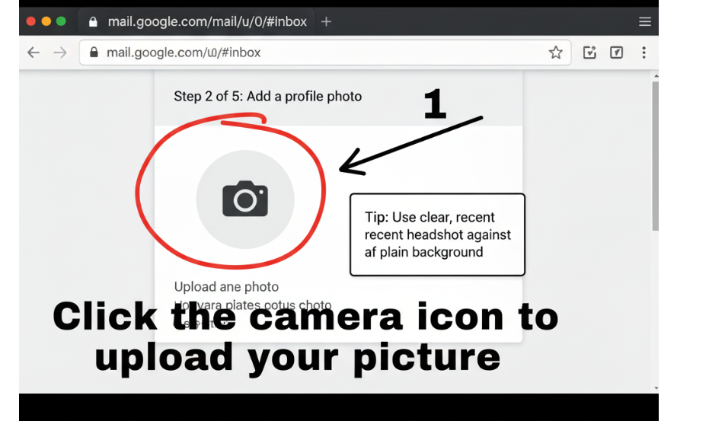

**Step 9: Add a Headline**

Write a **short, descriptive headline** that combines your job title with key skills.

Example: “Marketing Specialist | SEO & Analytics.”

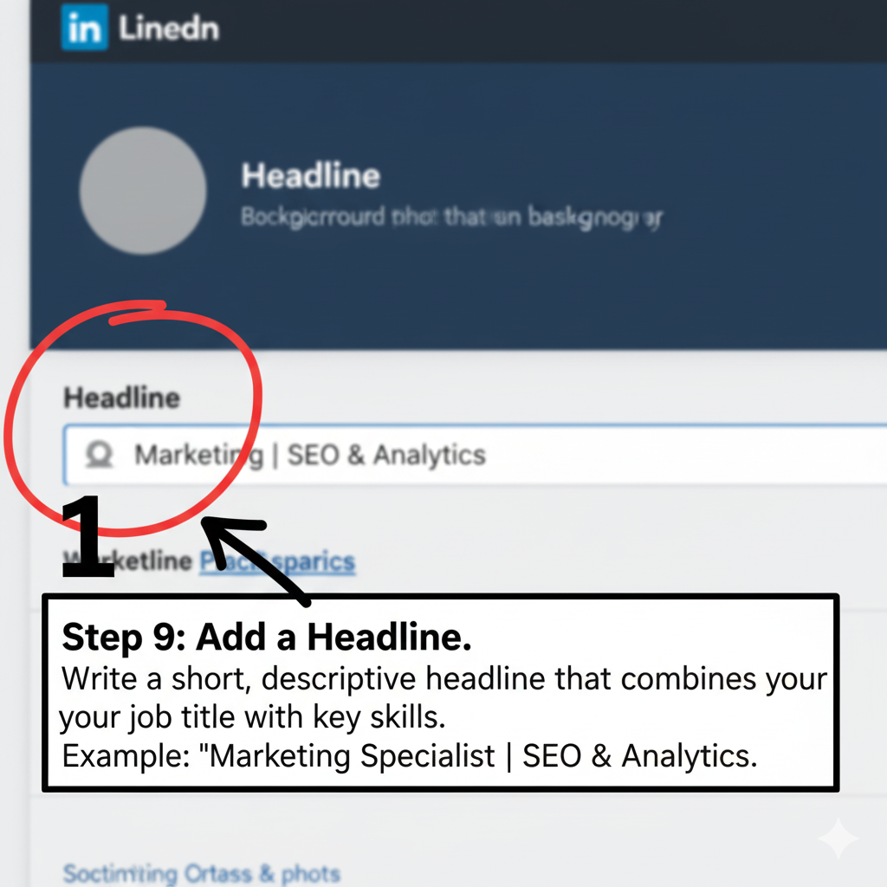

**Step 10: About Section**

Click the **pencil icon** in the “**About**” section.

Write 3–5 short paragraphs summarizing your skills, experience, and goals.

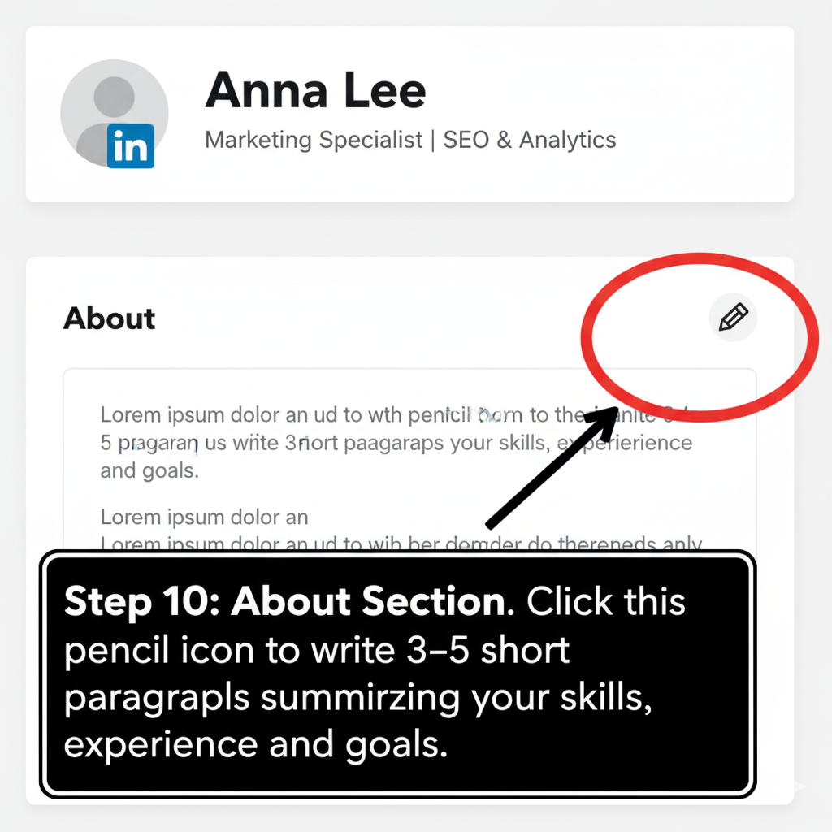

**Step 11: Experience or Education**

Click the plus (+) icon in the Work Experience or Education section.

Add dates, details, and a brief description (use bullet points if possible).

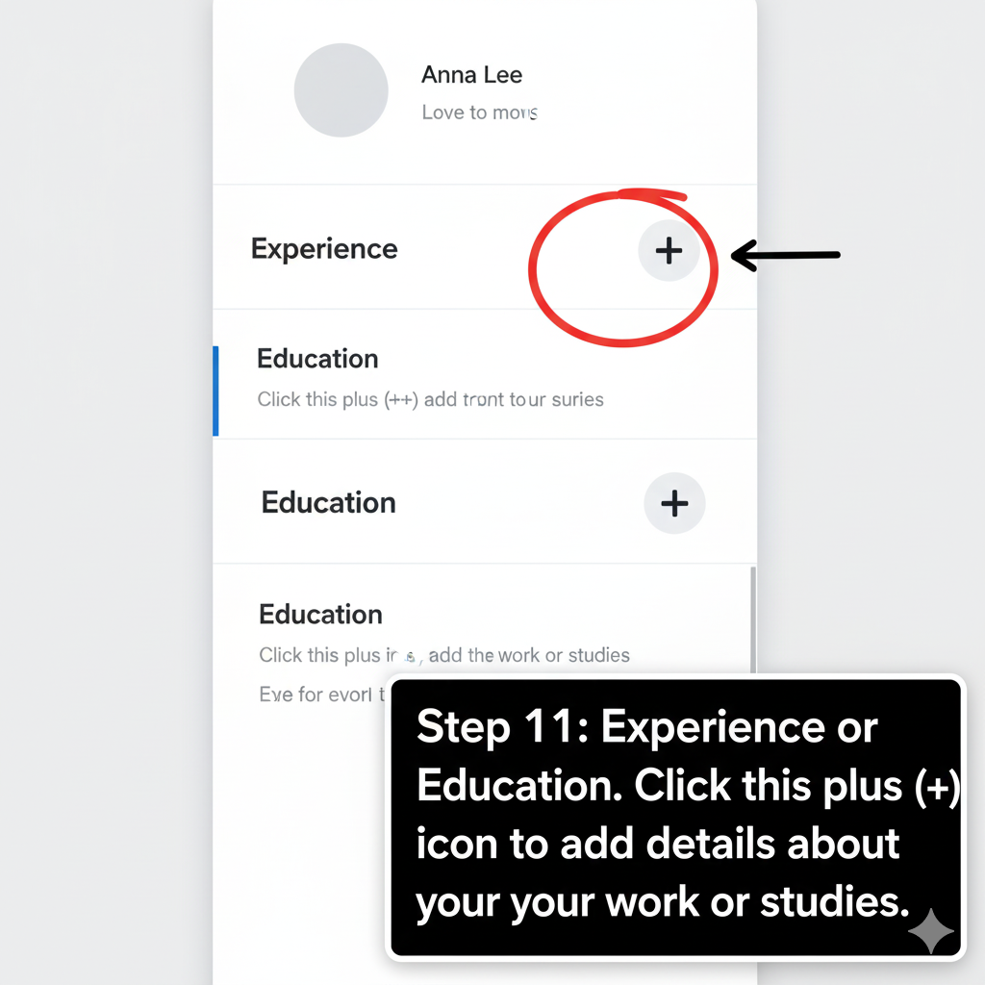

**Step 12: Completed Profile**

Review your new LinkedIn profile.

Make sure you’ve added at least one photo, headline, **About section**, and work **or education entry.**

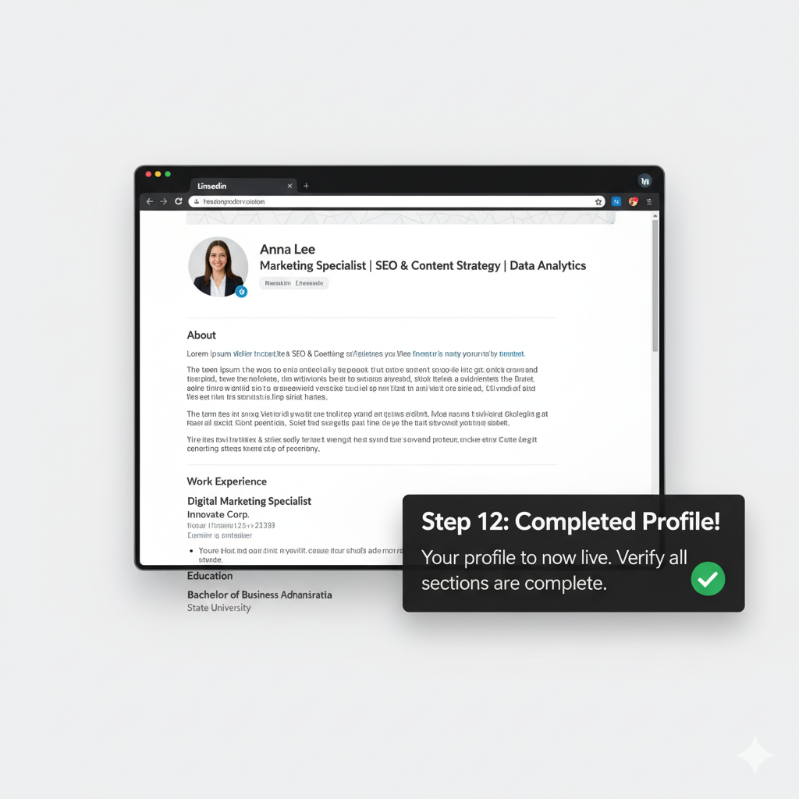

User Testing Feedback (Peter's Feedback) 🗣️

**I asked my friend Peter to review the draft and he said:**

**- Step 2** was confusing. I saw both **'Join now'** and 'Sign in' buttons. I clicked **'Sign in'** first because I thought **'Join now'** was just for companies. I got stuck there and had to restart.

**- Step 10** wasn't detailed enough. I didn't know what a compelling headline was. I just typed my current job title, but the instructions implied I should do more. I needed a better example.

**- Step 12** felt vague and stressful. When it asked for a **'brief description'** for my work experience, I froze. Does that mean a full paragraph, or just two sentences? I wish it had given me a format to follow.

## Revised Instructions 🛠️

**Revised Step 2:**

**Click the prominent 'Join now' button** to begin creating your account.  
 **CRITICAL ALERT:** Do not click **'Sign in**.' The option is only for users who already have an account.

**Revised Step 10:**  
**Write a strong, descriptive Headline** (the short phrase directly beneath your name).

**Action:** Combine your current job title with 2–3 key skills or specialties.  
Example: Instead of 'Sales Associate,' write: **'Sales Associate | Customer Relationship Management (CRM) | Inventory Analyst.'**

**Revised Step 12:**

**Add at least one Work Experience or Education entry** by clicking the plus (+) icon (+) on the respective section.

**Format**: Provide a description using **3–5 concise bullet points** that detail your responsibilities and, where possible, quantify your achievements.

Focus on actions, not just titles (e.g., Managed client accounts and processed 25+ daily transactions).

## Reflection 🧠

The testing phase with Peter was an essential step in refining the instructions. It confirmed that assumptions about user knowledge are the greatest threat to technical clarity.  
  
The revisions focused on making the **instructions more explicit, prescriptive, and context-specific**. For Step 2, I added an immediate **Critical Alert** to prevent Peter's error of confusing 'Join now' with 'Sign in,' directly addressing the initial user roadblock**. For Step 10**, the abstract goal of being 'compelling' was replaced with a concrete, actionable format: combine the job title with key skills, reducing the mental effort required to complete the field. Finally, the revision to **Step 12** solved the user's anxiety over writing style by providing a clear structure **(3–5 bullet points**) and tone (**focus on actions and quantification).**  
This process underscores the technical writing best practice **of usability testing and iterative design**. Instructions are not complete until a typical user can follow them flawlessly. By observing Peter, I learned that technical writing must not only be accurate but must also **anticipate** **cognitive load** and minimize ambiguity by providing clear formatting and explicit examples.

## References 📚

Kolin, P. C. (2022). Successful writing at work (12th ed.). Cengage.  
  
Redish, J. C. (2010). Technical communication and usability: Intertwined strands and mutual influences. IEEE Transactions on Professional Communication, 53(3), 191–201. https://doi.org/10.1109/TPC.2010.2052850